**FREE FOOD!!!**

**CRAYON CORNER LEARNING CENTER**

**OPEN HOUSE!!!**

**409 Washington St. Gladbrook**

**Saturday September 28th 4pm – 7pm**

CCLC would like to extend an invite to residents of Gladbrook and the surrounding area to come check out the recently updated daycare and learning center. There will be **FREE FOOD, jump house, and inflatable obstacle course.**

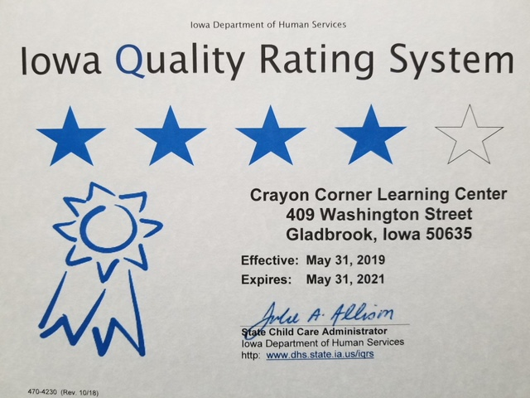

Tama County’s **ONLY** 4 Star Center